A transformational leadership technique that can be highly effective is the use of an Alignment Report shared with your leader on a weekly basis. This is NOT a status report and should not include updates on the most important activities. The primary purpose of an Alignment Report is to share your thinking on specific topics with your leader providing an opportunity to get feedback and ultimately, alignment on a direction.

The way it works is you tell your leader that you plan to send an alignment report to them on a weekly basis. Choose a day when you can allocate 60-90 minutes to collect your thoughts and prepare an Alignment Report. Make it clear that you expect your leader to respond to the Alignment Report in one of three ways:
- Suggest that you seek additional information that they are aware of before making the specific decision shared
- Ask you to reconsider the decision/direction you suggested
- No response, which indicates alignment with the direction/decision shared
You need to make it clear that any response to the email must come within 1 business day of receipt of the Alignment Report. No response (#3) indicates alignment with the decision and/or direction proposed.

It is common to share a decision/direction that you are considering with your leader along with a rationale for the decision. When sharing a rationale, use this format:

Rationale: The primary purpose for sharing a rationale for a proposed decision is to help your leader understand your thought process and how you came to a conclusion for a specific decision.

Transformational leadership requires leaders to make decisions on changes in direction to yield different results/outcomes. It is often challenging to get one-on-one time with your leader on a regular cadence due to travel schedules. Often individual meetings get bumped for special events or other priorities. The Alignment Report enables you to get feedback on key decisions regardless of whether you have a one-on-one meeting with your leader or not. Talk to your leader when you introduce the concept of an Alignment Report and ensure that they understand that you are expecting a response within 1 business day or you will assume their alignment or support for the decision. So if you send an Alignment Report on a Friday, you should expect a response from your leader by EOD Monday. If there is no response, you will assume that your leader is aligned with your stated decision. There will be cases where your leader is aligned with most of your decisions (outlined in your Alignment Report) but not all of them and your leader is responsible for letting you know when you need additional information before making the decision.

On the next page (page 2), I’ve included a sample of an Alignment Reports for you to see and understand. I’ve created these two samples as an illustration of what an Alignment Report looks like. I use bullet points to make it faster to prepare (not prose) and ensure that it is concise. There is a second example on page 3 for you to review.

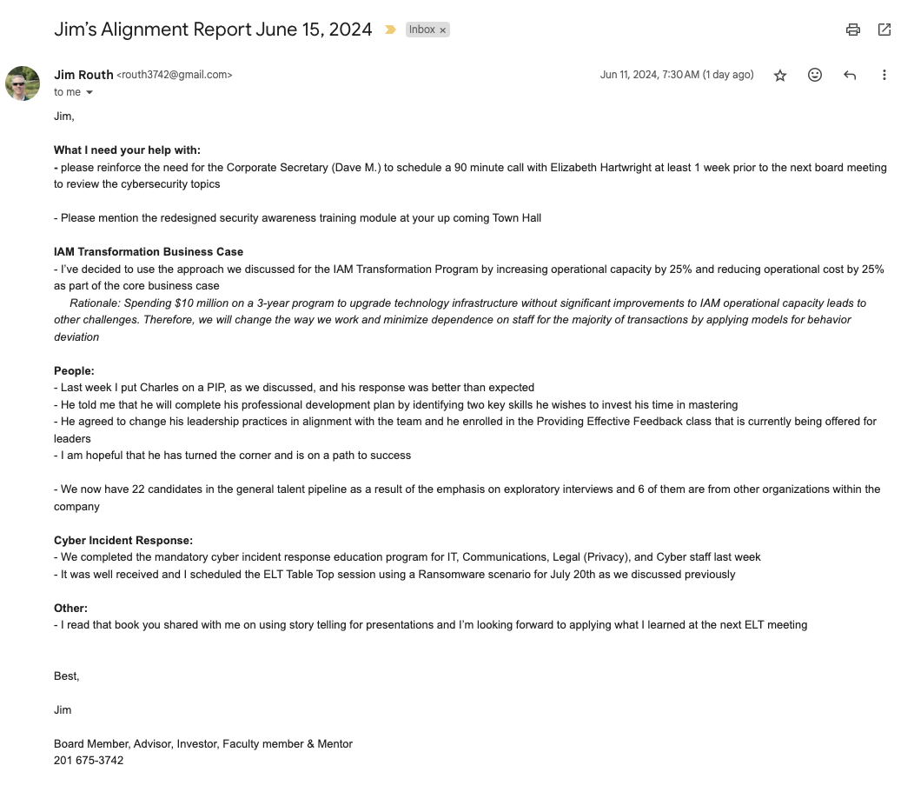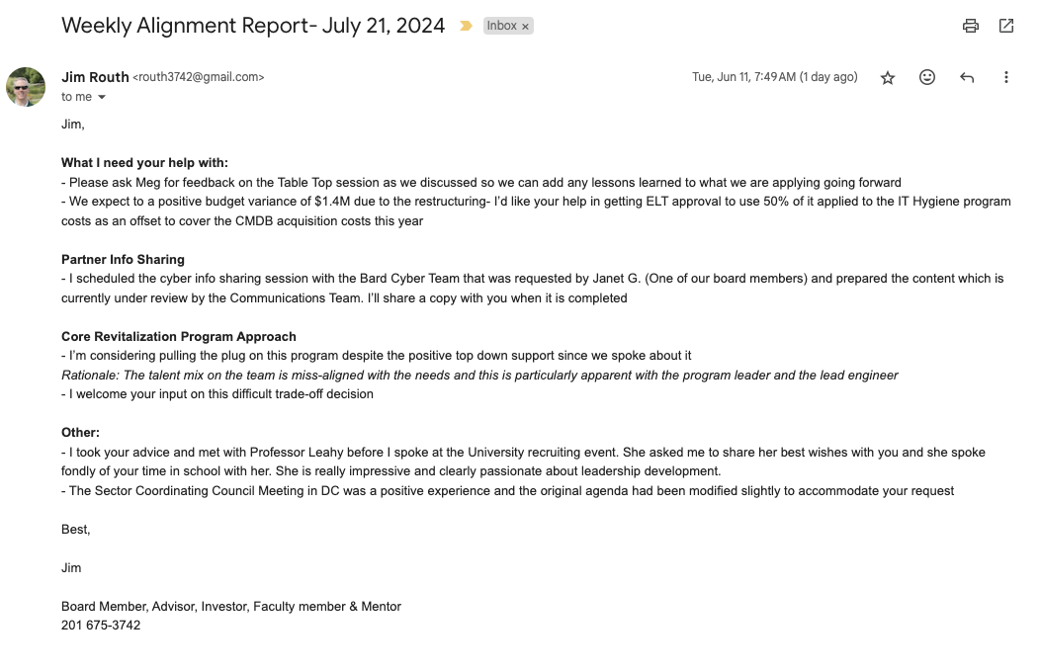

Both sample Alignment Reports reflect topics that I’ve used in the past and I always received positive feedback from my leader on the use of Alignment Reports. There is no need to take a lot of time to prepare them so if you set aside an hour a week, that should be ample time for you to focus on a few key decisions needed.

The first category is key, “What I need your help with.” This gives you an opportunity to manage up and making your expectations clear on what you need from your leader. My recommendation is to limit the number of “asks” of your leader to 1-3 requests per week [less is more].

Selecting the next category/topic is up to you and it can and should change from week to week. Focus on where you plan to make decisions with the potential for big impact to the organization and enterprise. Provide a little bit of context and then share the decision/direction that you wish to share. Add a rationale for this decision if you think it is needed. Write concisely and get your message across with as few words as possible. I typically would select 2-3 categories/topics each week. You may want bunch smaller topics together under the “Other” category.

I believe what you will find if you put the Alignment Report into practice is that your leader will have more insights into how you make decisions and what’s important to you beyond the business objectives for the year. As an example, your leader will better understand your thinking regarding leadership and talent development based on the people related decisions that you identify.

When you gain alignment on the use of the Alignment Report and you go through the ground rules with your leader, make it clear that this is for your leader’s benefit and your benefit. These emails should not be shared with other leaders or employees without your permission. They should represent a private interaction with your leader and these emails should not be forwarded to others.

This is a valuable technique for transformational leaders that is not cyber specific and can be used in any type of leadership change agenda. I encourage you to give it a try and solicit feedback from your leader on how effective it becomes.

